Temperature Trends:

A Brief Comparison of Moving Average Temperatures for 5 Cities and the Globe

# Background/Summary

Global temperatures have been cycling up and down for over 800,000 years (A Natural Climate Cycle, 2020). Ice ages have been interspersed with warmer periods, while atmospheric CO2 levels fluctuate accordingly. However, the wide-spread use of fossil fuels and petroleum based products, beginning during the Industrial Revolution, has caused the latter period of the Holocene epoch (often referred to the Anthropocene or ‘Age of Man’) to see a rise in atmosphere CO2 levels of 2 ppm/year, reaching levels higher than any other time during the last 800,000 years (Climate Change: Atmospheric Carbon Dioxide, 2020).

The brief report that follows will provide some explanation of global temperature data and examine the details of a very limited data set for the world and five selected cities. This data will be compared utilizing moving averages and simple difference between maximum and minimum (final and initial) data values.

Contents

Background/Summary 1

Modern Temperature Trends 1

Global Temperature Trend 1

Local Temperature Trends 2

5 cities and the global average 3

Conclusions 4

References 6

Submission details 6

Outline: 6

SQL 6

Word 8

# Modern Temperature Trends

To summarize, this rapid accumulation of CO2 is not healthy for our world. However, many find it hard to comprehend or “see” on a daily basis. To simplify some of these concepts, let’s take a look at almost three hundred years of modern temperature data to identify any significant trends and make some basic comparison.

## Global Temperature Trend

First, we will look at the global temperature data from 1750 to 2013 utilizing a 25-year moving average. For those who are unfamiliar with this type of data, global temperature is calculated utilizing multiple different sources generally averaged over a period of around 30 years (Explainer: How do scientists measure global temperature, 2015).

Figure 1 - Global average temperature data (1750-2013) smoothed with a 25-year moving average.

As you can see in the figure above, the temperature fluctuated until the late 19th century and has steadily increased since that period. In fact, since the late 1980s some areas of the world have seen a temperature increase of over 0.5°C with 9 of the 10 hottest years occurring since 2005 (Climate Change: Atmospheric Carbon Dioxide, 2020). This is a very worrying trend and it can be seen in many cities and regions around the world.

## Local Temperature Trends

Locally, the city of Raleigh, North Carolina has seen its own temperature increases.

Figure 2 - Global and Raleigh, NC average temperature data is shown here, again using a 25-year moving average.

Raleigh has always been hotter than the global average and continues to be so. Over the last 200+ years its temperature has fluctuated in a similar, albeit more erratic, manner compared to the global average. This similarity is further emphasized by the fact that both Raleigh and the global average have seen almost identical increases of 1.3°C in average temperature when comparing their 25-year average temperatures in 1774 to the ones in 2013.

## 5 cities and the global average

When looking at data like this it is always important to consider other comparisons. Is Raleigh an outlier which has greater conformity to the global temperature trends than other cities? Or is Raleigh right in line with other cities? Additionally, are there any cities out there which do not show as much increase in temperature as the global average or maybe an outright decrease?

Unfortunately, due to resource and time constraints, this report will not be looking into as many cities as it both could and probably should. Instead, 5 were chosen based on the writer’s personal travel interests and current location (hence Raleigh, NC). The other four cities are Edinburgh, Scotland; Tokyo, Japan; Rio De Janeiro, Brasil; and Dublin, Ireland. Below in Figure 3 you can see the Global average temperature and 5 selected cities. It is important to note that there were missing data figures in the 1700s for Raleigh, Dublin, and Edinburgh and Tokyo and Rio de Janeiro did not even have data until the mid 1800s. Subsequently, the data displayed below is based on the earliest possible continuous, uninterrupted data for each city. This means that the temperature timeframe is somewhat shortened, but still provides a 25-year moving average from 1875 to 2013. This period captures the majority of the first and all of the second industrial revolution and the consistent elevated temperature increase from the 1970s to today. Despite the shortened observational period, it is clear that there has been an increase in average temperature of around 1°C for each city.

Figure 3 - This figure displays the 25-Year Moving Averages for Rio De Janeiro, Tokyo, Edinburgh, Dublin, Raleigh, and the world from 1875-2013. All of these 5 cities have uninterrupted data from 1875 forward, so this is a somewhat shortened picture.

As you can see, while some of the less temperate/tropical areas see less dramatic of an increase, all 5 cities share similar trajectories and see consistent increases in temperature over this period. In Figure 4 you will see the initial and final average temperature and the difference between the two.

|  |  |  |  |  |  |  |
| --- | --- | --- | --- | --- | --- | --- |
| **Year** | **Global** | **Raleigh** | **Dublin** | **Edinburgh** | **Tokyo** | **Rio de Janeiro** |
| 1875 | 8.12 | 14.17 | 8.62 | 7.50 | 12.21 | 23.44 |
| 2013 | 9.35 | 15.28 | 9.48 | 8.46 | 13.38 | 24.62 |
| *Difference* | *1.23* | *1.11* | *0.85* | *0.95* | *1.17* | *1.18* |

Figure 4 - A comparison of initial and final 25-year moving averages for each of the 5 cities and the global average temperature over the period for 1875-2013 seen in Figure 3.

# Conclusions

This report will leave any true scientific conclusions and extrapolations to the professionals who have spent much of their lives trying to understand this data and prognosticate about the future. However, sheer visual inference and basic math on the provided data indicates a very worrying trend. It is hard to comprehend how an annual average temperature increase can cause so much concern, but these images from the recent IPCC Special Report will help put it into proper perspective. 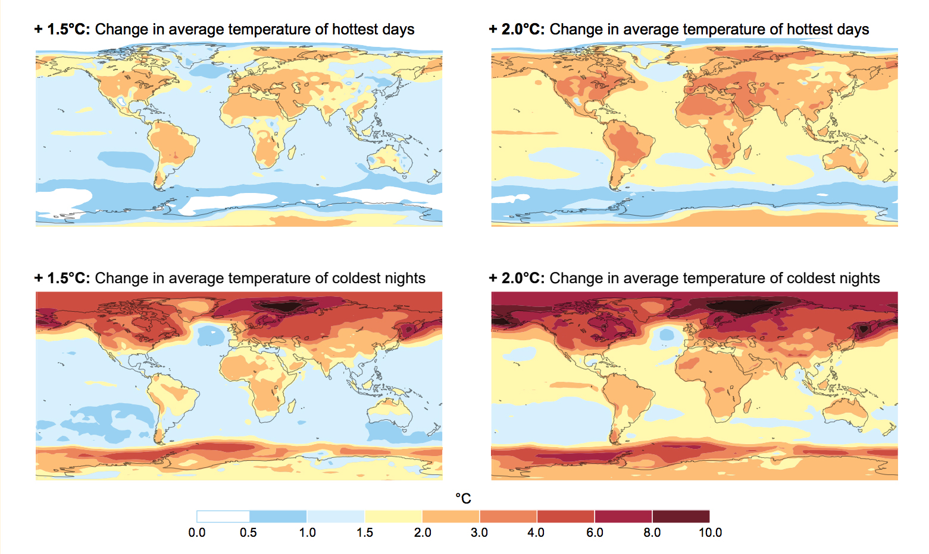

Figure 5 - An image from the Intergovernmental Panel on Climate Change Special Report on Global Warming of 1.5º Celsius (2.7º Fahrenheit) (Global Warming of 1.5 Degrees C, 2018)

What this chart demonstrates is the difference 0.5°C of global temperature change can have on the daily high and lows seen around the world. This global average temperature is largely determined by the amount of energy the world receives from the sun. A one to two degree increase in temperature is worrying as the same decrease is all it has taken in the past to trigger small ice ages (Global Temperatures, n.d.).

Our world has seen significant increase in annual average temperature around the world. Without consistent, significant efforts from every nation, this trend could continue. These temperature increase may be something our modern society thinks it can overcome, but much of the world will be unable to cope with the rapid temperature change. In fact, studies warn that by 2070 around 1/3 of all species could be under the threat of extinction (Rice, 2020). Even this limited analysis of temperature data shows that our society must make substantial changes or face a very difference and uncertain future.

# References

*A Natural Climate Cycle*. (2020, July 25). Retrieved from Committee on Climate Change: https://www.theccc.org.uk/the-science-of-climate-change/climate-variations-natural-and-human-factors/a-natural-climate-cycle/#:~:text=The%20Earth's%20natural%20climate%20cycle,period%20of%20about%2010%2C000%20years.

*Climate Change: Atmospheric Carbon Dioxide*. (2020, February 20). Retrieved from Climate.gov: https://www.climate.gov/news-features/understanding-climate/climate-change-atmospheric-carbon-dioxide#:~:text=The%20global%20average%20atmospheric%20carbon,least%20the%20past%20800%2C000%20years.

*Explainer: How do scientists measure global temperature*. (2015, January 16). Retrieved from Carbon Brief: https://www.carbonbrief.org/explainer-how-do-scientists-measure-global-temperature

*Global Temperatures*. (n.d.). Retrieved from NASA Earth Observatory: https://earthobservatory.nasa.gov/world-of-change/global-temperatures

*Global Warming of 1.5 Degrees C*. (2018). Retrieved from IPCC: https://www.ipcc.ch/sr15/

Rice, D. (2020, February 14). *One-third of all plant and animal species could be extinct in 50 years, study warns*. Retrieved from USA Today: https://www.usatoday.com/story/news/nation/2020/02/14/climate-change-study-plant-animal-extinction/4760646002/

# Submission details

## Outline:

### SQL

The data was collected form SQL using the following queries:

SELECT city, country, year, avg_temp

FROM city_data

WHERE city LIKE 'R%' AND country = 'United States'

ORDER BY 3

SELECT year, avg_temp

FROM global_data

SELECT g.year as "Year", g.avg_temp as "Global Avg Temperatures", c.avg_temp as "Raleigh Avg Temperatures"

FROM global_data g

JOIN city_data c

ON c.year = g.year

WHERE city = 'Raleigh'

ORDER BY g.year

SELECT g.year as "Year", g.avg_temp as "Global Avg Temperatures"

FROM global_data g

ORDER BY g.year

SELECT c.avg_temp as "Raleigh Avg Temperatures", c.year as "Year"

FROM city_data c

WHERE city = 'Raleigh'

ORDER BY c.year

SELECT c.avg_temp as "Tokyo Avg Temperatures", c.year as "Year"

FROM city_data c

WHERE city = 'Tokyo'

ORDER BY c.year

SELECT c.avg_temp as "Dublin Avg Temperatures", c.year as "Year"

FROM city_data c

WHERE city = 'Dublin'

ORDER BY c.year

SELECT c.avg_temp as "Rio de Janeiro Avg Temperatures", c.year as "Year"

FROM city_data c

WHERE city LIKE 'rio%'

ORDER BY c.year

SELECT c.avg_temp as "Edinburgh Avg Temperatures", c.year as "Year"

FROM city_data c

WHERE city = 'Edinburgh'

ORDER BY c.year

#### Excel

The data was downloaded into CSV files and combined in Excel. I was uncertain which cities I wanted to use initially and subsequently selected for them all individually as I made decisions. Then the average temperature data was converted into a 25-year moving average, as I felt this was a reasonable period which to smooth the data over and evaluate any trends. It was only after I finished all the charts and most of my report that I learned most climate data utilizes a 30-year moving average. Needless to say I did not restart the project given the close proximity of each moving average. The moving average was calculated by utilizing the expressions “=AVERAGE(G1:G25)” and then filled for each subsequent year to 2013 (G1 to G25 is just an example period).

Line charts were then created to provide proper visualization of these moving averages. Initial and final values were displayed, and the charts were all labeled for clear understanding of what data is being displayed. Additionally, one simple table was created to numerically calculate the difference in average temperature.

### Word

The charts and figures were then added to a word document which was filled out with background information and relevant data to help better frame the discussion and inform the reader about the significance of any data trends discovered in the analysis performed using moving averages. The 4+ observations were not explicitly called out in the design of the document, but they can be identified and displayed if the reviewer wishes them to be handled that way. MS Word formatting was utilized to create a clean, organized document. Finally, this document had the project outline details added and was saved in PDF form and submitted.

### Citations and

All relevant information which was not considered common knowledge to the writer was properly cited, as seen above in the References section of this document.